Coursera Applied Data Science Capstone
IBM Data Science Professional Certificate
Re: Jupyeter Notebook: IBM-Course-9-Capstone-week_5.ipynb
Final Project

Week 5 – Final Report

1.0 Introduction

1.1 Business Problem and Client Perspective:

A newly certified Realtor is also new to the Portland, Oregon region. Now that she has earned her real estate license she wishes to familiarize herself with the character of the different neighborhoods in the Portland Metropolitan area and wishes to be able to identify which neighborhoods are similar to each other. This will help her identify neighborhoods that would be most productive to “farm” for business in and will help her guide her clients to potential homes in areas they may not have previously considered. She is interested in characterizing the neighborhoods using a combination of real estate related data including sales and ownership info, educational attainment of residents, income, poverty, and employment statistics, commuting info, walking score, and the different types of venues available in the neighborhood for residents and vistors to enjoy.

2.1 Data Description and how it will be used to solve the problem.

Data will be pulled from the following sources:

2.2.1 WIKIPEDIA https://en.wikipedia.org/wiki/Neighborhoods_of_Portland,_Oregon
A google search produced a number of potential sources for a list of Neighborhoods in the Portland area. The data was in a disjointed format that made writing a python scraper problematic so I copied and pasted them into a csv file instead. The search raised the question of whether or not neighborhood names are subjective such that names that people reference, including in apps like Foursquare, are not captured in offline lists like wikipedia pages. However, for the purpose of this exercise the list is sufficient for proceeding with the analysis.
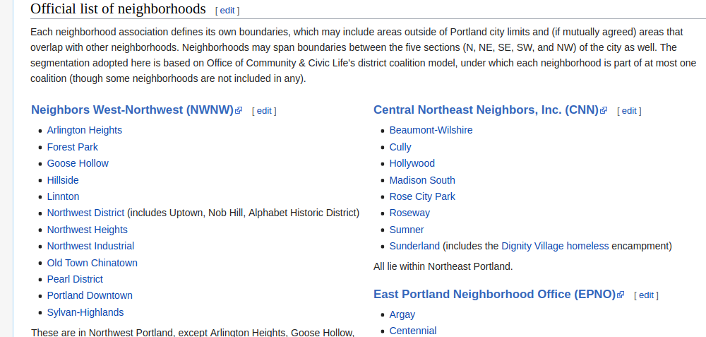

2.2.2 FOURSQUARE https://foursquare.com/
Foursquare provides a location platform that provides a search and discovery mobile app that provides City Guide type information along with realtime location sharing and checking in. The app allows users to rate and comment on local venues and provides the opportunity for realtime trending of venues. Foursquare has over 105 million places in its database worldwide. For the purpose of this exercise I will be using a free developer account with limited access. This will allow modeling of the machine learning approach but the data will not represent the complete dataset that is available from Foursquare.

This data source doesn’t represent the full set of businesses or venues in an area but it does provide an interesting approach to finding those businesses and venues that people are checking in on via social media with a real-time perspective.

2.2.3 GEOCODER https://geocoder.readthedocs.io/
Geocoder is a simple and consistent geocoding library written in Python. Geocoder will be used to find coordinates for the neighborhoods in the analysis.

2.2.4 PORTLAND MONTHLY https://www.pdxmonthly.com/articles/2017/3/22/portland-neighborhoods-by-the-numbers-2017-the-city
Portland Monthly is a monthly news and general interest magazine which covers food, politics, business, design, events and culture in Portland, Oregon. The magazine publishes an annual guide to 122 Neighborhoods in Oregon with categories for Neighborhoods, Real Estate, People, Median Rent, Median Income, Population Density, Crime, Parks, Transit, Minutes by Car to Downtown, and Walk Score. Each category has a summary provided in the article that describes the method and source used for the data. Crime data was not updated at the time of this analysis and so could not be included. The data is available in a table form and is readily scraped via typical python methods. Some of the columns are not of interest for this analysis, others are duplicates in the content provided so there will be some pruning of the data required, selecting the most appropriate value, such as using park land as a % of the neighborhood area rather than the number of acres of park land. Further, there is a total for each column in the last row at the bottom of the table that will need to be removed. There appear to be differences between the neighborhoods provided here and those obtained via the csv sheet, reconciling the two is beyond the scope of this exercise but would be performed as part of a more formal machine learning project.
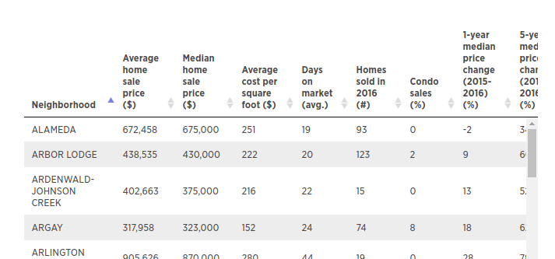
2.2.5 SUMMARY:
The selected data sources together represent a broad set of neighborhood demographics and characteristics directly relevant to people who are making a choice about the neighborhood they would like to live, work, or play in. Therefore, it follows that there is an opportunity to leverage this data to explore similarities between neighborhoods that can help guide prospective clients to neighborhoods that they may have overlooked. A more complete analysis would obviously include other datasets such as school ratings but that is beyond the scope of this exercise. The data will be prepared and processed, and normalized before running it through a K-Means Clustering analysis.

3.0 METHODOLOGY:

3.1 Steps Followed:
Define the problem statement
Conduct google searches to investigate and identify potential data sources
Prepare csv file of list of neighborhoods
Prepare code to scrape demographic data from URL
Install dependencies with pip
Install packages with import
Define Foursquare credentials
Import Portland Neighborhood data from a csv file into a dataframe
Use Geocoder to get geographical coordinates for the neighborhoods
Use Folium to create a map with the neighborhoods appropriately labeled
Use Foursquare calls to Explore the neighborhoods for different venue types
Create a dataframe using One-Hot-Encoding to prepare for clustering
Import Portland Real Estate and Demographic data by scraping a table from the web
Clean the dataframe by removing columns not relevant to the analysis
Visualize each of the features in demographic data using bar charts to identify problem areas and correct them or remove the column if not needed. Look for any features impacted by outliers that need to be handled.
Merge the two data sets, Foursquare and Portland Data using an inner join
Remove any string columns
Normalize the data to provide a common scale for the clustering algorithm
Run K-Means algorithm on the data
Add the clustering labels and add the ‘Neighborhood’ column and column labels back in
Create a map showing the neighborhoods marked with the cluster label and a unique cluster color
Count the number of neighborhoods for each cluster
Create horizontal Bar Charts with top 20 feature scores (normalized) for each of the clusters
Evaluate the results from the original business perspective and experiment with changes to the Foursquare radius and number of clusters.

3.2 I chose the K-Means Clustering algorithm to categorize neighborhoods using a set of numeric features from which I wanted to extract groupings of neighborhoods based on similarities that are not immediately evident using other methods. I also chose to normalize the data because of the presence of some features that had very large numbers up to the millions and other features that had very small numbers less than 1, normalizing helped limit the opportunity for bias by evaluating all features on a scale from 0 to 1

4.0 RESULTS

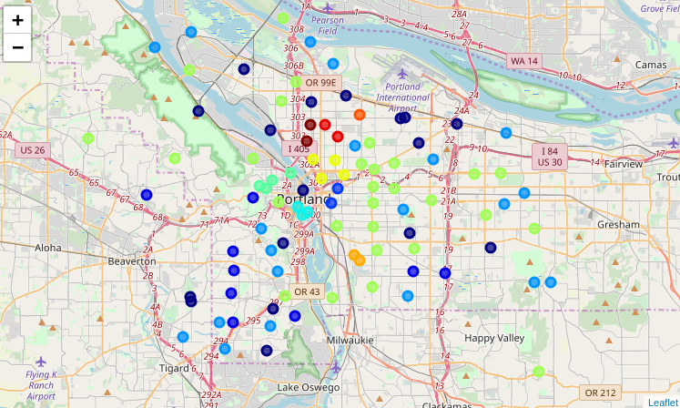
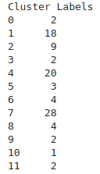

4.1 The analysis provided 12 clusters ranging in distribution from 1 to x. Analysis of the highest feature scores shows a diverse mix of defining features in the different neighborhoods. The count of neighborhoods per cluster shows clusters ranging from 1 neighborhood per cluster up to 28 neighborhoods per cluster. Horizontal bar charts are provided for each of the clusters.

4.2 Cluster 1 shown below is distinguished from other neighborhoods by categories like ‘Percent of families with children under 18 (%)’, ‘Population in same house last year’, ‘Home Ownership’, etc. A check of a google search confirms that this neighborhood is an affluent family neighborhood.

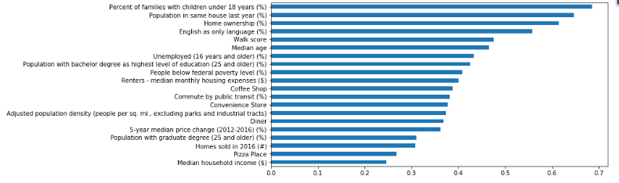

4.3 Cluster 10 below describes a single neighborhood with a unique diversity of restaurants, galleries, hotel bars, and music venue. A google search of the Concordia Neighborhood in Portland describes a neighborhood with a university, galleries, restaurants, suggesting that the algorithm made an appropriate characterization. https://www.urbannestpdx.com/life-in-portland/2016/8/25/an-all-purpose-guide-to-the-concordia-neighborhood-in-portland

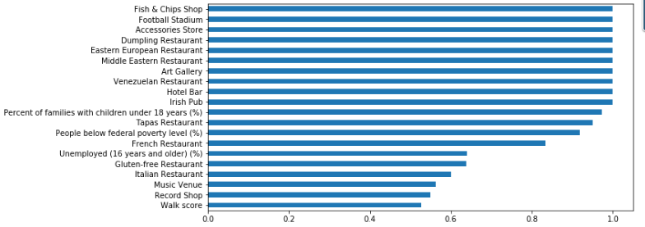

5.0 DISCUSSION

5.1 Clusters are developed from a discrete set of data inputs which have a degree of variability and subjectivity that need to be considered in order to avoid unintentional bias in the output. The Foursquare data provides unique and useful insights to trending locations and venues but the data provided will reflect the demographic of the Foursquare app users which may or may not align with other demographics whose interests aren’t represented. Also, on subsequent iterations it would make sense to explore the app for better aggregation of the data. For example, separating all of the different ethnic restaurant types has the effect of potentially diluting the impact of having a diversity of ethnic restaurants in a neighborhood as a whole. It also doesn’t necessarily make sense to provide a feature like “caribbean restaurant” with the same weighting as a feature like “average home sale price”, and distinguishing neighborhoods based on a Caribbean cuisine feature and an Ethiopian cuisine feature isn’t necessarily meaningful vs a potential single feature that could be derived from them that captures the amount of diversity in local restaurants. The selection of data sources seems appropriate for a quick ad-hoc analysis but a more authoritative and enduring source should be considered if this were to be intended as an ongoing tool for reference.

5.2 The number of clusters is entirely subjective given the intended purpose and the correct number would be arrived at by working with end users / realtors based on their feedback, seeking a balance between the number of clusters produced vs the uniqueness of the clusters. It is likely that ‘Neighboorhood’ is too general a concept and it would be worth considering making the clusters based on a grid capable of providing more granularity than the existing ‘Neighborhood’ category can. The initial run of the Foursquare app used a radius of 500m but this produced an unacceptably large number of clusters with only one neighborhood. By increasing this value to 1000, a value that is consistent with general practices for estimating a neighborhood size based on a google search
+ produced fewer single neighborhood clusters, allowing for more comparisons to be made between similar neighborhoods.
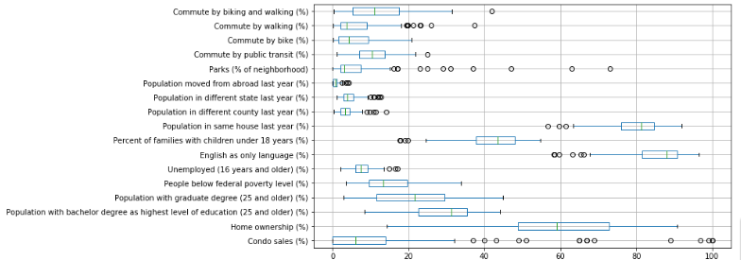

5.3 Boxplots were useful in analyzing the distribution of the features and the presence of outliers. Some features could be groupped together if they had a common scale such as %, but others were best represented one their own not in combination with others in order to best represent the distribution of the feature. In the case of features like “Median home sale price ($)” the presence of outliers means there are some neighborhoods with much higher sales prices than others. A cursory review of the values suggests the values are reasonable, reflect actual market variations, and should not be removed from the data but instead left as-is. Boxplots also helped identify features such as ‘Population moved from abroad last year (%)’ that had very little variation, low frequency and no outliers suggesting these features could be removed as they didn’t provide any meaningful distinction between any of the neighborhoods even if they were present.

5.4 Boxplots show that the data from Foursquare is fairly sparse. This could be addressed by building a function that takes the Foursquare category taxonomy json file and uses it to look up a more generalized category for each of the venues. This is beyond the scope of this project but would potentially provide a more meaningful analysis through a more logical groupings of the venues rather then using them at the detail level.

6.0 CONCLUSION
6.1 The analysis provides a proof of concept for accessing publicly available data from a variety of sources to produce an analysis that makes a meaningful distinction between different neighborhoods in the Portland area sufficient to inform a newly certified real estate agent of the similarities between different neighborhoods. K-Means clustering is a useful tool for conducting this analysis. To improve on this analysis would require a more thorough investigation of available alternate data sources from official sources like the federal, state, or local governments, social media platforms, real estates data providers, etc. Another improvement that may be more useful for a realtor would be to construct clusters based on street addresses rather than neighborhoods, or by constructing quadrants and comparing them based on the characteristics of the addresses within them. The best approach would be one that is an iterative process developed and refined over time based on feedback of actual user experience.

